Timesheet

**Timesheet User Requirements Specification**

**Version 1.0a**

**02 August 2020**

**Prepared by**

**Ashutosh Goswami**

**Revision History**

|  |  |  |  |
| --- | --- | --- | --- |
| **Name** | **Date** | **Reason for changes** | **Version** |
| Ashutosh Goswami | 02 August 2020 | draft | 1.0a |
|  |  |  |  |

**Table of Contents**

1. **EXECUTIVE SUMMARY………………………………………………………………………………..4**
   1. PROJECT OVERVIEW……………………………………………………………………………………………….4
   2. PURPOSE AND SCOPE OF THIS SPECIFICATION………………………………………………4
2. **PRODUCT/SERVICE DESCRIPTION…………………………………………………………..4**
   1. PRODUCT CONTEXT………………………………………………………………………………………………..4
   2. USER CHARACTERSTICS………………………………………………………………………………………..4
   3. TECHNICAL CONSIDERATION……………………………………………………………………………….4
   4. CONSTRAINTS………………………………………………………………………………………………………….5
   5. DEPENDENCIES……………………………………………………………………………………………..5
3. **REQUIREMENTS**
   1. FUNCTIONAL REQUIREMENTS………………………………………………………………………………5
      1. *Users*…………………………………………………………………………………………………………………………..5
      2. *Managers*…………………………………………………………………………………………………………………11
      3. *Administrators*………………………………………………………………………………………………………..13
   2. SECURITY…………………………………………………………………………………………………………………19
      1. *Protection*………………………………………………………………………………………………………………..19
      2. *Authorization and Authentication*……………………………………………………………………...19
4. Executive Summary
   1. **Project Overview**

Timesheet project aims at creating an efficient web application which would help a firm to manage and track their employee’s day-to-day contribution on different projects and project managers to manage their team members without much overhead.

* 1. **Purpose and Scope of this Specification**

**In Scope**

This document addresses requirements related to Phase 1 of Timesheet project:

* Providing Login screen for a User.
* Dashboard to show functionalities available to a specific User.
* Managing Employee’s data.
* Activities related to different types of users

**Out of Scope**

The following item can be in future phases of Timesheet project:

* Activities related to the management of leaves
* Bill generation for the client

1. Product/Service Description

Current system is based on physical record keeping, management and has following concerns that need to be addressed:

* Multiple files need to be managed
* Time taken for processing is longer due large no files.
* Tracking of time spent on a project by different project members is difficult
  1. **Product Context**

Product outcome of phase 1 will be and efficient, user friendly web application where different users can file their working hours. Project Member can be assigned to a Project and Managers can view their team member’s contribution and project progress.

* 1. **User Characteristics**

Application will be used by the following groups:

* Admin
* User
* Manager
  1. **Technical** **Consideration**
* Web Application will be built using Asp.net mvc structure with .Net framework version 4.7.
* MS SQL Server 2014
  1. **Constraints**
* Access to system will be managed and controlled by Admin.
* User systems should be running at least on dual core processor with 4GB RAM.
  1. **Dependencies**
* The employee information maintained in physical files.
* Admin has to enter details to System.

1. Requirements

**\*The Mock-screens provided below are for references actual project**

**may not have the same screens. \***

* 1. **Functional Requirements**

The functional requirements are captured in the usability flow manner of each group of users. Admin Should set up access for each user and assign them their respective roles.

* + 1. **Users**

Timesheet application will open by entering the Url on the browser. User will see the Login screen as shown below:

* + - 1. **Login Screen:**

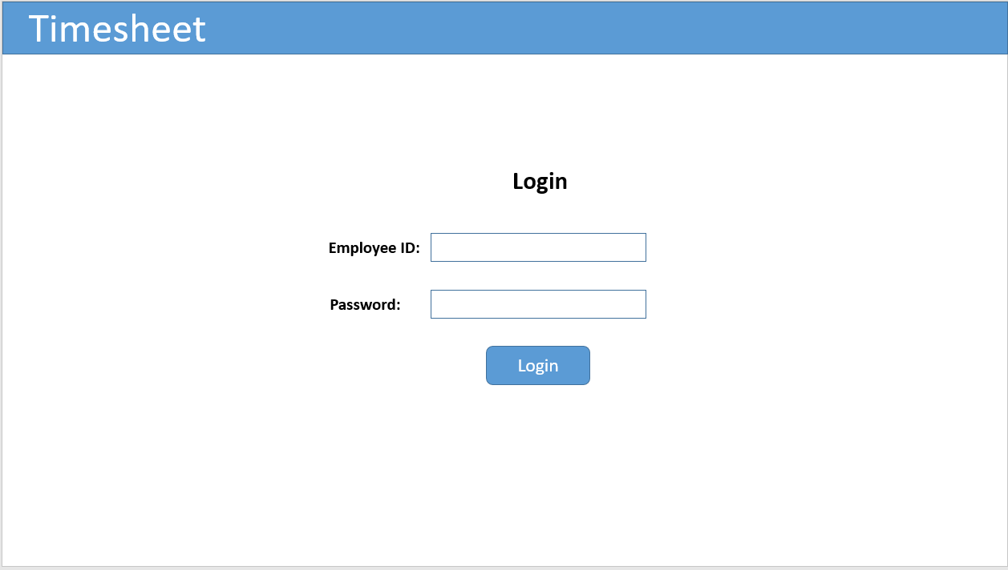

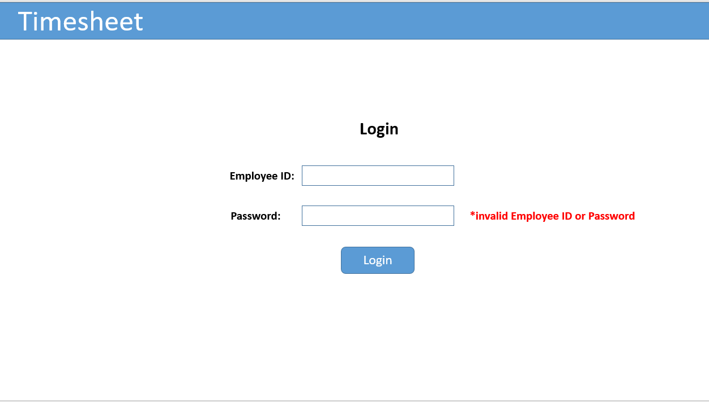

* User will use the Username provided through email to login to the application
* Type in the username and password and click on submit
* User is provided with a forgot password in through which user will be redirected to the password reset page (contact admin)

If the credentials entered are incorrect the User is displayed an error message on the screen. Once the credentials are validated user will be successfully logged in and he will be directed to his dashboard screen.

* + - 1. **Dashboard Screen:**

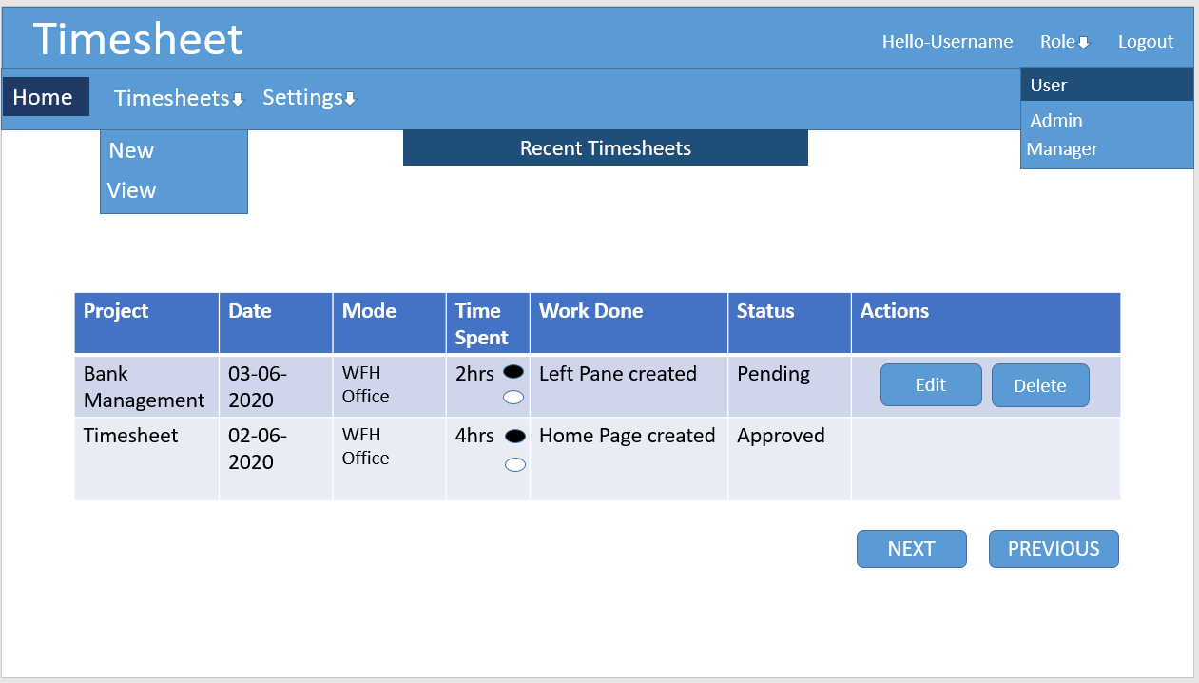

* User will see his Username on the top right corner.
* Adjacent to it, user’s role is displayed e.g.: ‘User’ or ‘Admin’.
* Next to that there is a dropdown which displays all the roles a user has been assigned.

For e.g.: Admin, User, Manager. On the top of the menu there are different options for creating new timesheet and settings dropdown providing option to change the password

* View Option will redirect the user to view all the timesheets filed.
* Recent Timesheets will be displayed according to the date with option to edit or delete the timesheet on the home tab.
  + - 1. **Timesheet**

1. **New Timesheet Entry**: A new Timesheet can be created by using the menu and selecting the new option, the below screen will be displayed.

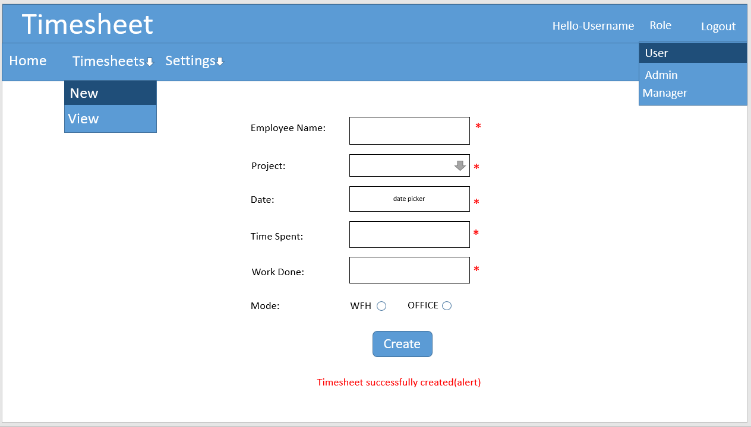

* User will enter all the required fields and click on create button.
* The Project names will be fetched from the database and displayed on the dropdown.
* Date field will have a calendar control to pick the date.
* Respective errors will be shown if user does not and enter a required field and click on create.
* If all the details are entered correctly a new timesheet will be created with an alert that timesheet was created successfully.
* All the recent timesheets will be displayed on the recent pane such that user get to know his timesheet was created or not.

1. **Edit Timesheet Entry:** An existing timesheet can be updated by clicking the edit option present next to the timesheet entry, on clicking the below screen will be displayed:

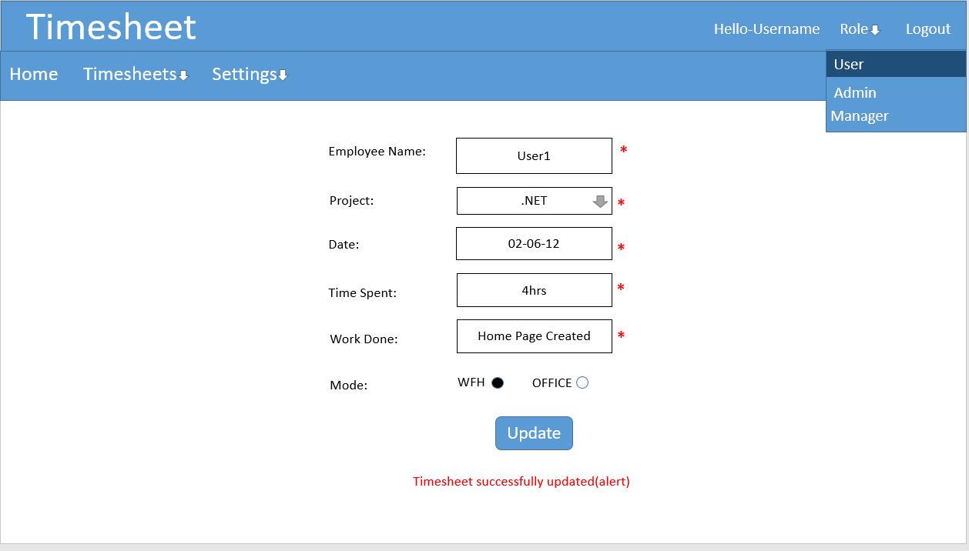

* The fields will be auto populated with the previous details mentioned, user can modify the details and click on the update button.
* The user will be shown an alert with message timesheet update successfully and the recent pane will be populated with the updated details.

1. **View Timesheet Entries:** All the timesheets filed by a user can view by clicking the view option present on the menu bar. On clicking screen below will appear.

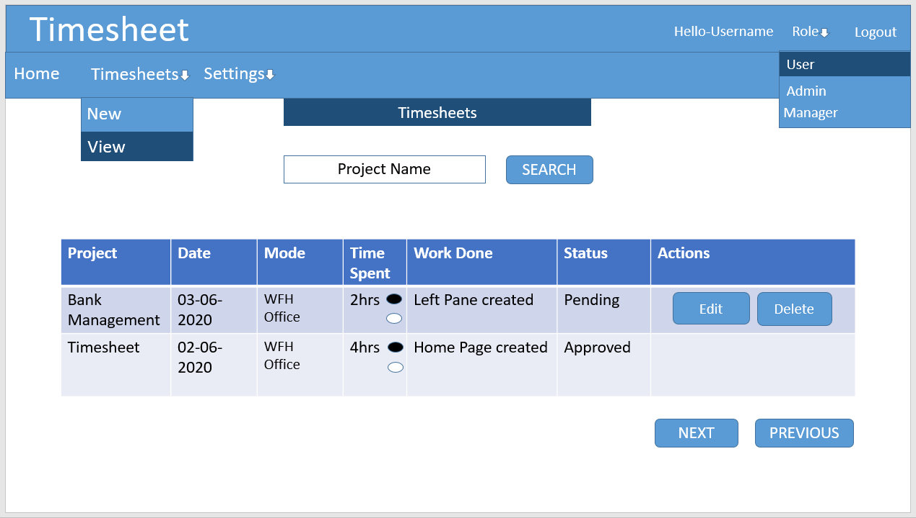

* User will be provided with option to filter/search timesheets based on project name.
* Options to edit and delete the timesheets will be provided next to the timesheet details.

1. **Settings:**

**Password:** User can change his account settings through settings dropdown next to it. User selects change password option by clicking the option the below screen will be displayed. As initially the password will be auto-generated, he may forget his password.

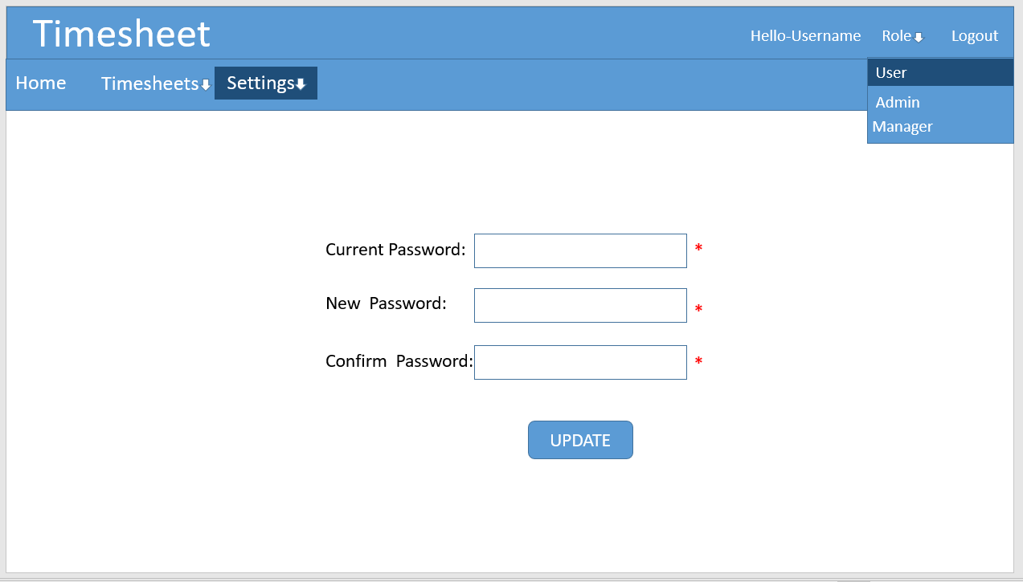

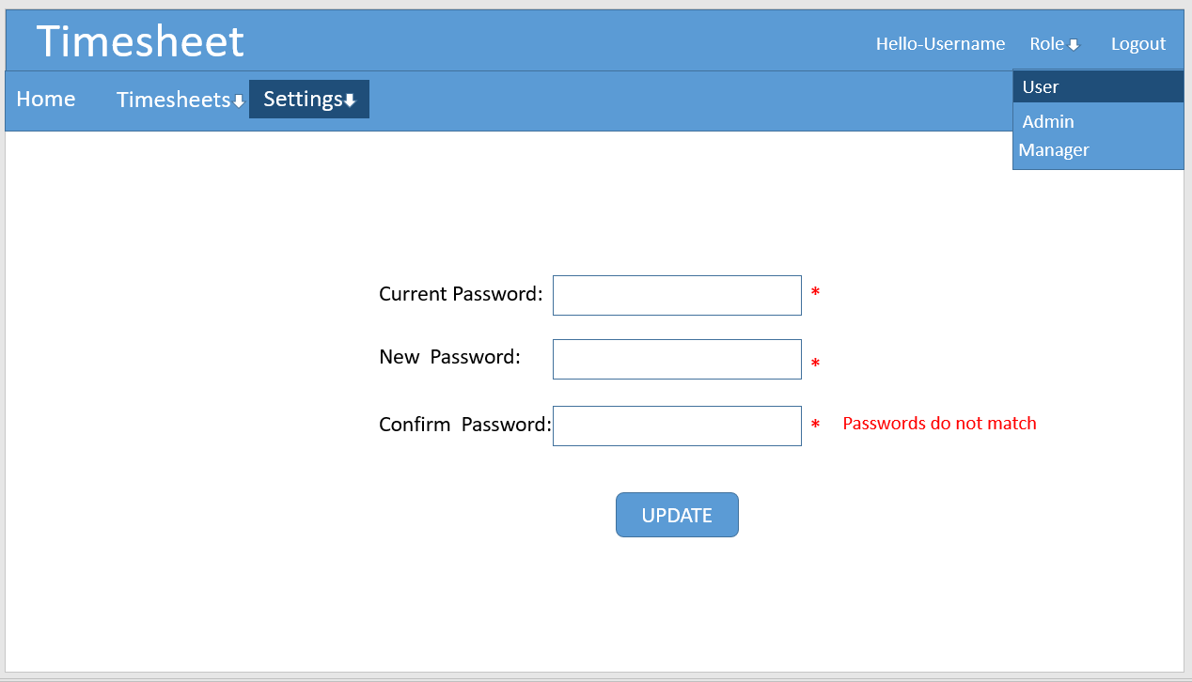

* User needs to enter all the required fields.
* User’s New and Confirm password should match otherwise the error message will be displayed accordingly.
* User will update the password by clicking on the update button and alert will be shown to him about password successfully updated.
  + 1. **Managers:** Manager user role has the rights to fill and manage his own timesheets, approve or reject timesheets of the project members.

Once a Manager has successfully logged in, he will be directed to his dashboard and screen will be displayed as below:

* + - 1. **Dashboard Screen:**

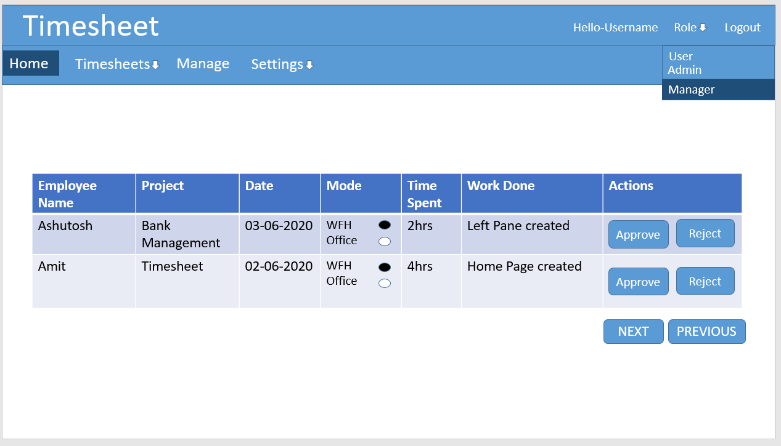

* Manager’s username will be displayed on the top right corner.
* Next to it there will be a dropdown to select other roles if user belongs to them also.
* On the menu bar there will be options to create new timesheet, view previous timesheets, manage Team members’ timesheets i.e. approve or reject them, settings option to change password.
* Managers will see the following on their dashboards:

1. **Recent Project Members Timesheets:**

Recently filed Timesheets by the Team members with different details such as Employee Name, Date of filing the timesheet, Project Name, Time Spent, Work Done,

Actions that can be taken by the manager for that timesheet i.e. approve or reject the timesheet

* + - 1. **Manage Screen:**

Managers will be redirected to manager screen where managers can see project member’s timesheet details.

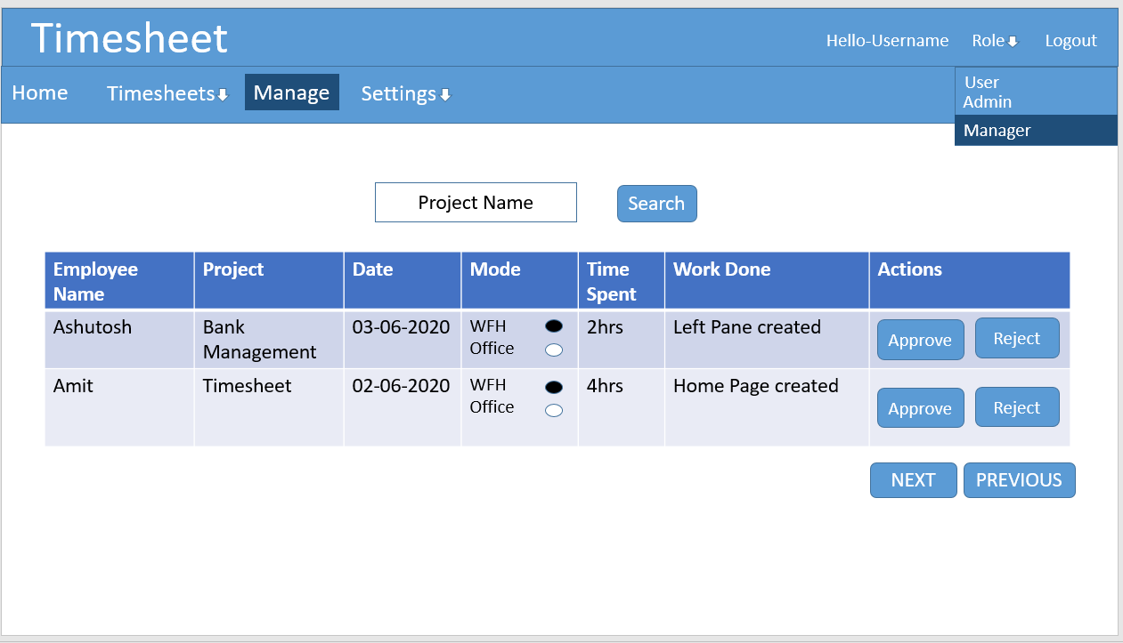

* Managers can see the details of the timesheets filled by the Team members on this page.
* Managers are provided with options to approve or reject the timesheets present on the right to the timesheet details.
* By clicking on the search option the Managers can search the timesheet according to the Project’s name.
  + 1. **Administrators**

Administrator user role has the rights to register new users to the system, assign roles to them, create project, assign members to the projects, manage the project details, create subtasks in the project, fill and view their own timesheets. Admin also handles user management i.e. change in the user details.

Once admin successfully logs into the application, he’ll be redirected to his dashboard.

* + - 1. **Dashboard Screen:**

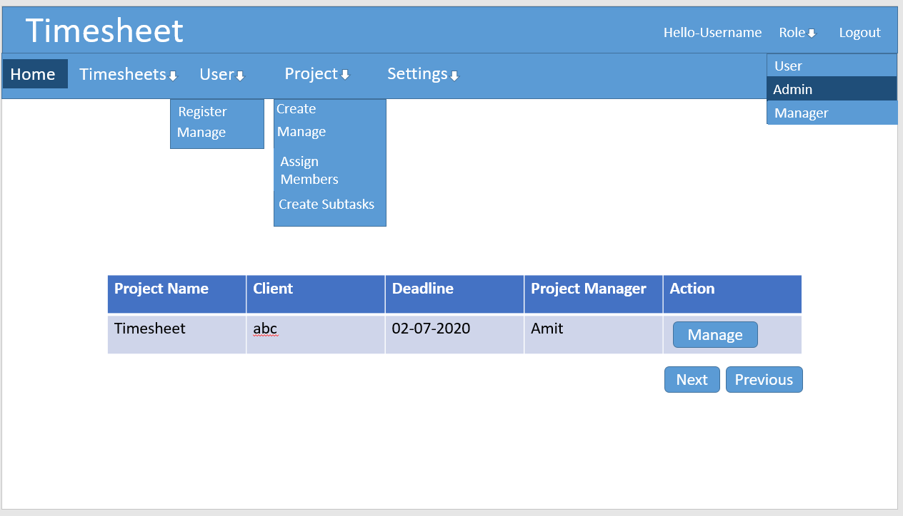

* Admin’s username will be displayed on the top right corner.
* Next to it there is a dropdown which display the role the user currently has i.e. Admin.
* Next to it there is a logout option through which the user can logout of the application.
* On the left side there are different options the admin can choose from the menu bar such as Home, Timesheets, Project and Settings.
* Admin will see the information about the Projects on his home screen/dashboard according to the closest deadline, on the information he is provided with manage action by clicking this the Admin can manage the Project details. Below screen will be displayed.

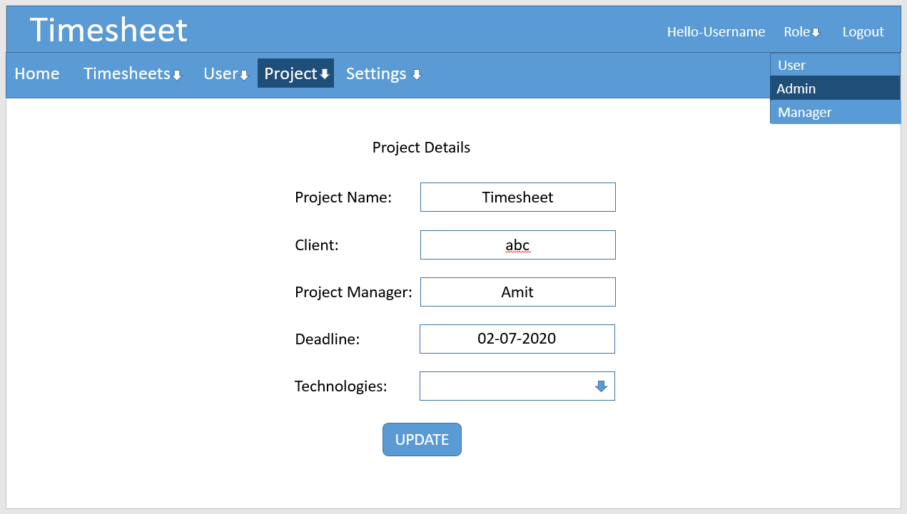

* + - 1. **Menu Options:**

1. **Timesheets:**

This dropdown provides the Admin to create new timesheets and view the previously filled timesheets the display screen would be same as ordinary user.

1. **User:**

This dropdown option provides the Admin privileges regarding the users of the application by clicking on the Register option from the options the user can register a user to this application so that the user can access the timesheet application. Below screen will be displayed after Admin chooses register option.

1. **Register:** Admin can register new users using the register option provided in the dropdown User.

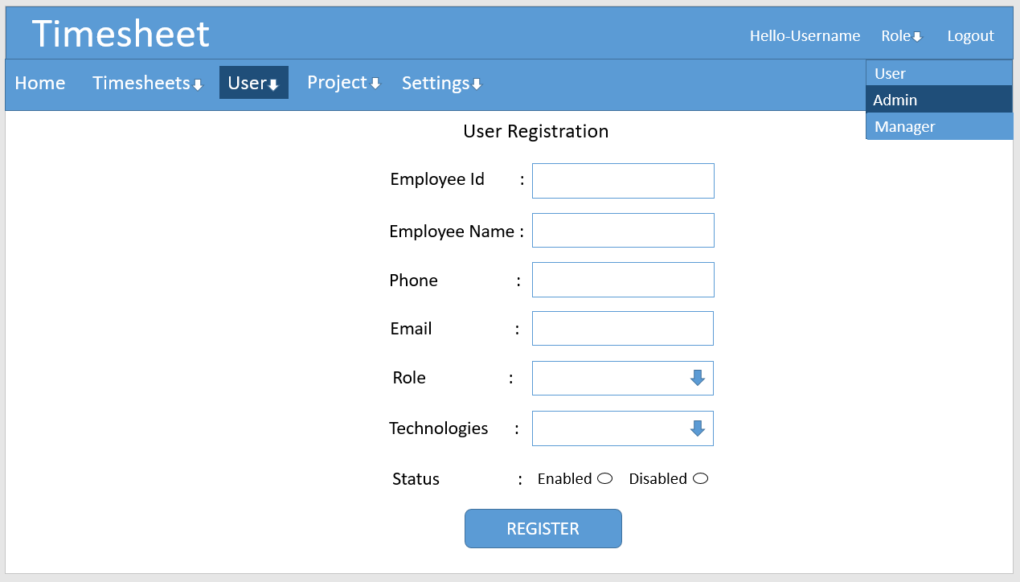

* Admin has to enter the various user details such as Employee Id, Employee Name, Phone, Email, Role, Technologies the user work upon and user status.
* Using the Role option, the user can be assigned a role from various available roles by choosing the option from the dropdown.
* Technologies that user work upon is selected using multi-select list.
* User’s current status can be set by Admin by choosing from the options Enabled or Disabled.

1. **Manage:** Admin can manage/edit user details by clicking on the manage option from the User dropdown. Admin will be presented with screen below:

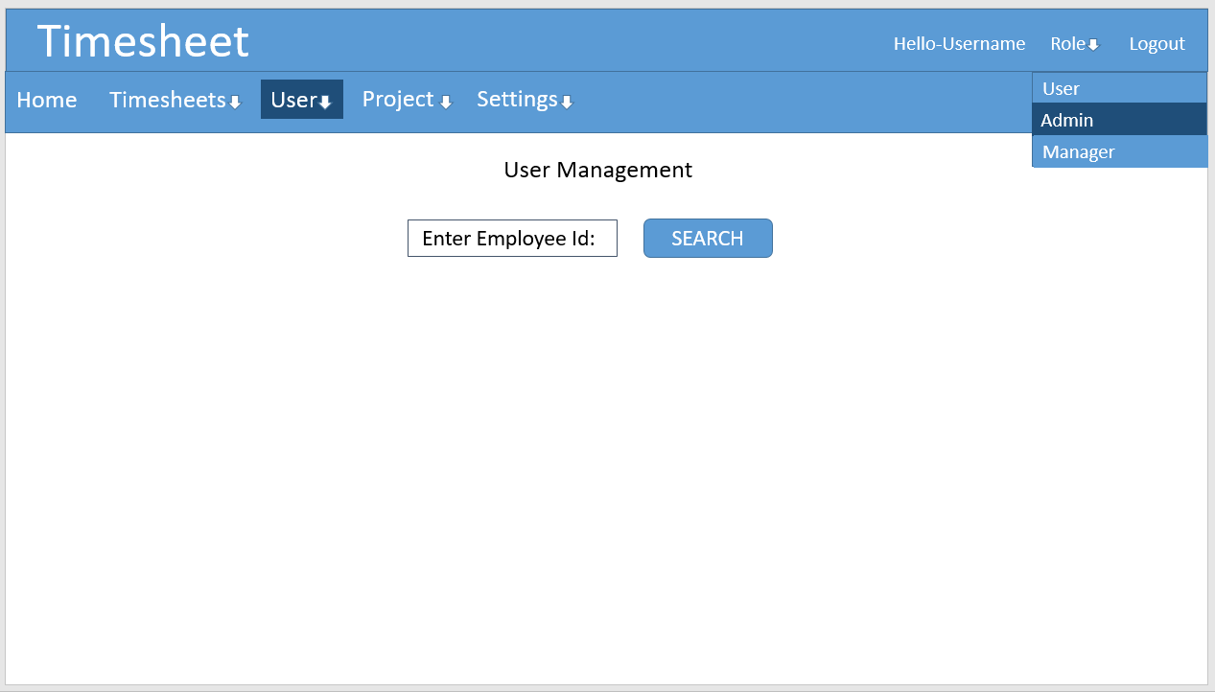

* There is textbox present through which Admin can find the user details by entering the Employee Id and clicking on the search button. Below is the screen displayed upon clicking search.

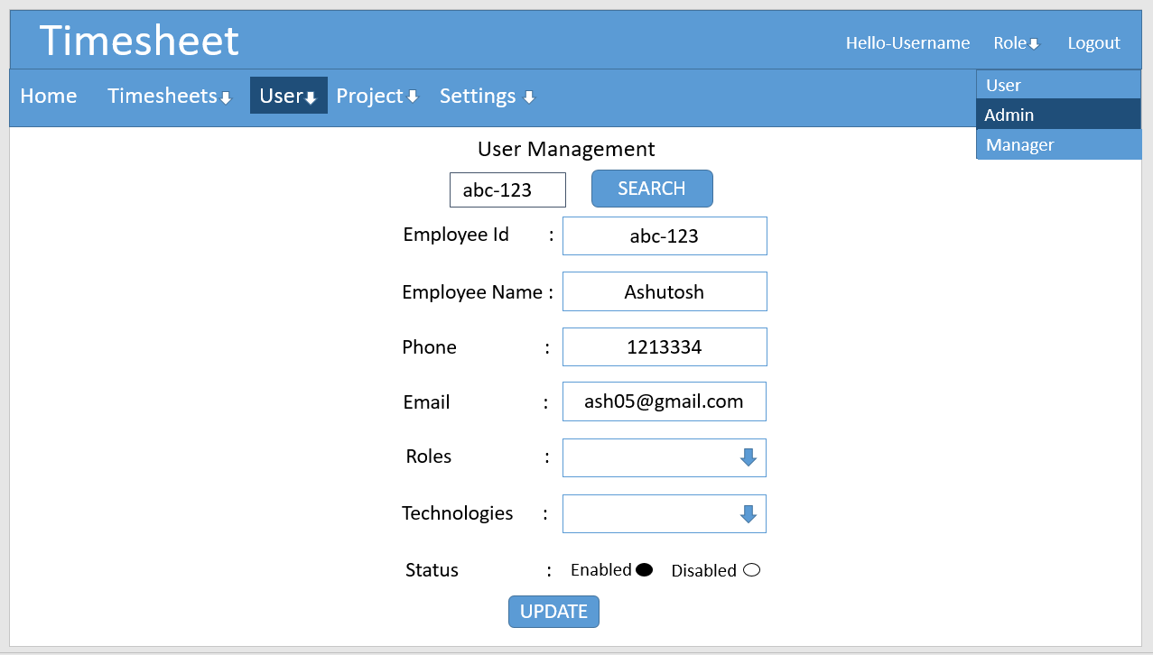

* The existing user details are shown to the Admin.
* After changing the user details Admin will click on update button this will update the user details.
* An alert will be used to show success or failure of the operation.

1. **Project:** Project menu option is a dropdown which provides the Admin with privileges such as Create Project, Manage Project, Assign Members to the Project and Create Subtasks to the Project.
2. **Create:** Admin can create new Project by clicking on the create option provided by the Project dropdown. Below is displayed on clicking create:

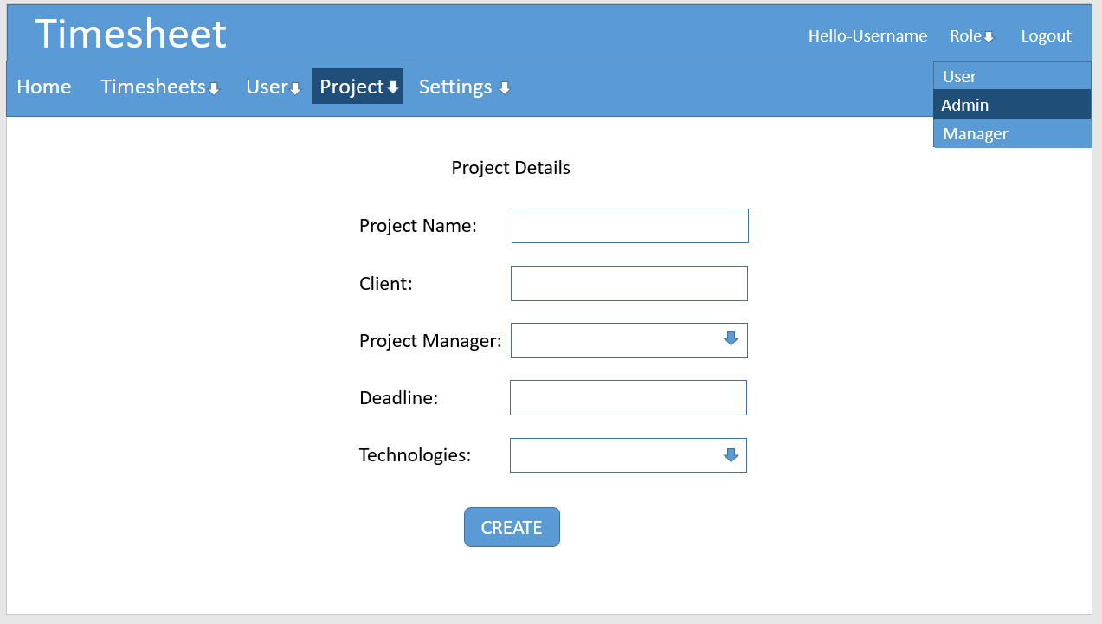

* Admin has to enter various details about the Project such as Project Name, Client, Project Manager through a dropdown, Deadline of the Project and the technologies used in the project.
* Upon entering all the fields Admin has to click the create button.
* An Alert will be displayed to show success or failure of the operation.

1. **Assign Members:** Admin can assign members to a project. Below screen will be displayed:

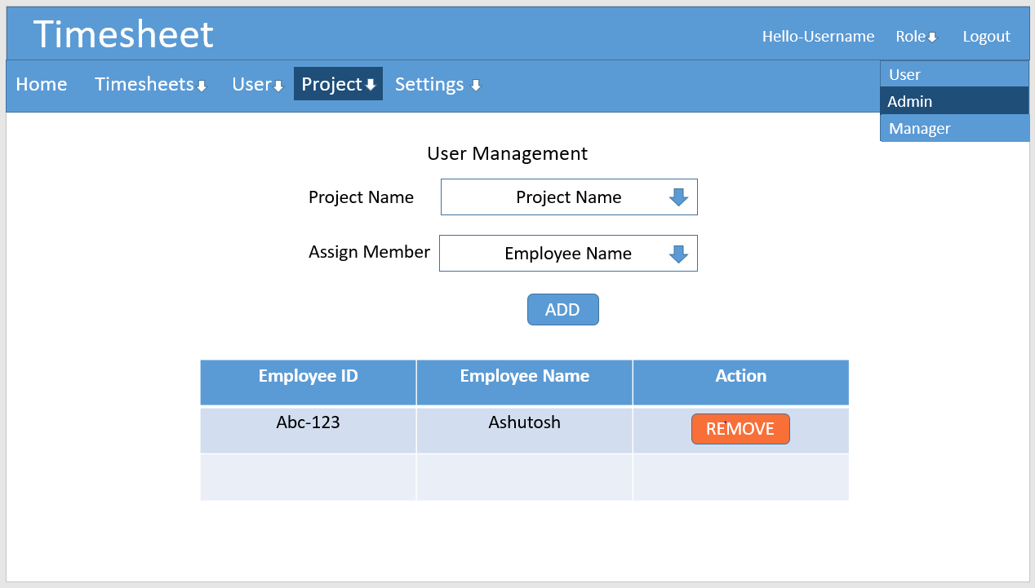

* Admin can select a Project by proving its name using the dropdown provided.
* After a Project is selected all the member associated to that project is displayed in the table below.
* Admin can select the employee using the dropdown which displays all the employees.
* Admin can add the employee to the project by clicking on add button.
* The table below will be updated with the addition of new member to the project.
* Admin is also provided with remove button through which he can remove an employee from a project.
* Add/Remove action is confirmed through an alert.

1. **Create Subtasks:** Admin can create Subtasks of a Project by clicking on the Create Subtasks option. Below Screen will be displayed:

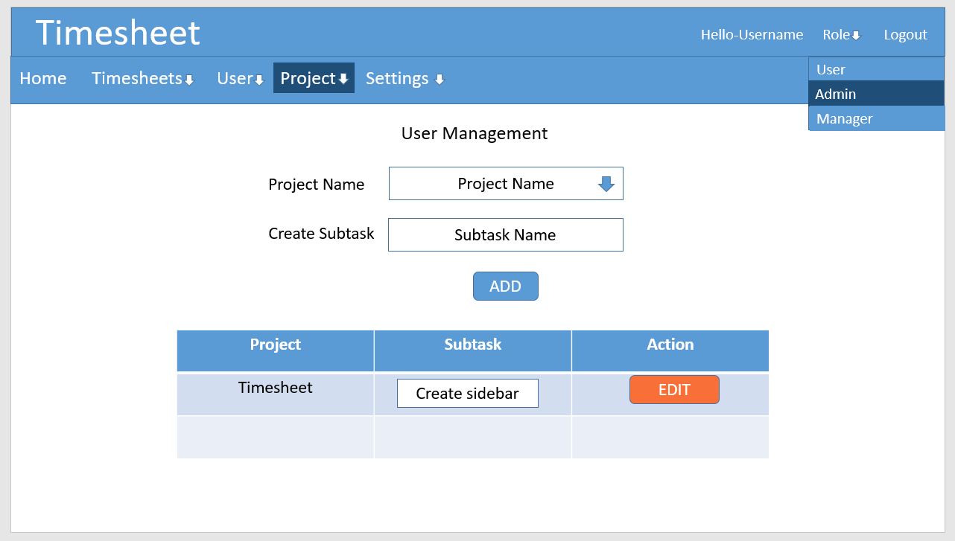

* Admin can select the project through dropdown provided.
* After the Project is selected already created subtasks are displayed with edit option through which the subtask can be edited.
* To create a new subtask Admin has to enter the subtask in textbox below the Project Name.
* Admin will create a subtask to the project by clicking on the add button.
* An alert will be used to show that subtask was created.
  1. **Security**
     1. **Protection**

To protect the system from malicious or accidental access, modification, following will be implemented:

* Only Authenticated users will be allowed in the system.
* Authorization of data is controlled by admin.
  + 1. **Authorization and Authentication**

Asp.net MVC role based authentication will be utilized.